DBMS LAB ASSIGNMENT-2

Name: Mankena roja

Rollno: 19bcs067

1. Show how to Create and Drop Database

QUERY

CREATE DATABASE TRAVEL

DROP DATABASE TRAVEL

Output

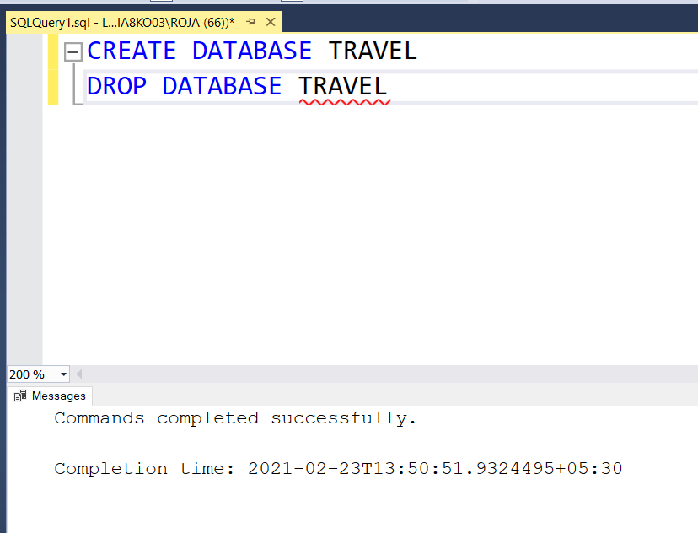

2.Show all the Databases are in the system

QUERY

SELECT * FROM sys.databases where database_id>0

Output

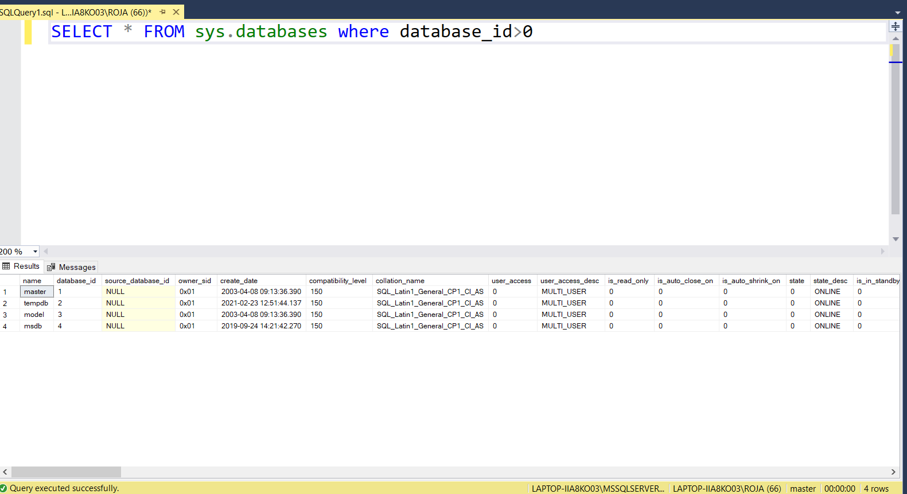

3. Create Table for your Database

QUERY

USE T10_TRAVEL;

CREATE TABLE T10_travel_database

(

agency_id INT PRIMARY KEY NOT NULL,

agency_name VARCHAR(250)NOT NULL,

agency_address VARCHAR(200)NOT NULL,

agency_description VARCHAR(45)

)

CREATE TABLE T10_customer_details

(

customer_id INT PRIMARY KEY NOT NULL,

customer_name VARCHAR(255)NOT NULL,

customer_mobile INT NOT NULL,

customer_email VARCHAR(45)NOT NULL,

customer_username VARCHAR(45)NOT NULL,

customer_password VARCHAR(45)NOT NULL,

customer_address VARCHAR(45)NOT NULL,

);

CREATE TABLE T10_booking_details

(

booking_id INT PRIMARY KEY NOT NULL,

booking_hotel_id VARCHAR(255)NOT NULL,

booking_type VARCHAR(45)NOT NULL,

booking_date INT NOT NULL,

booking_title VARCHAR(45),

booking_description VARCHAR(445)

);

CREATE TABLE T10_hotel_details

(

hotel_id INT PRIMARY KEY NOT NULL,

hotel_name VARCHAR(255)NOT NULL,

hotel_type VARCHAR(45)NOT NULL,

hotel_rent INT NOT NULL,

hotel_description VARCHAR(45),

hotel_address VARCHAR(465)NOT NULL,

);

CREATE TABLE T10_tour_details

(

tour_id INT PRIMARY KEY NOT NULL,

tour_agent_id VARCHAR(40)NOT NULL,

tour_customer_id VARCHAR(45)NOT NULL,

tour_name VARCHAR(45)NOT NULL,

tour_type VARCHAR(45)NOT NULL,

tour_place VARCHAR(45)NOT NULL,

tour_description VARCHAR(45)

);

CREATE TABLE T10_package_details

(

package_id INT PRIMARY KEY NOT NULL,

package_tour_id INT NOT NULL,

package_name VARCHAR(45)NOT NULL,

package_amount INT NOT NULL,

package_total INT NOT NULL,

package_type VARCHAR(45) NOT NULL,

package_description VARCHAR(200)

);

CREATE TABLE T10_transportation_details

(

transportation_id INT PRIMARY KEY NOT NULL,

transportation_tour_id VARCHAR(255)NOT NULL,

transportation_name VARCHAR(45)NOT NULL,

transportation_type VARCHAR(45)NOT NULL,

transportation_description VARCHAR(200)

);

OUTPUT:

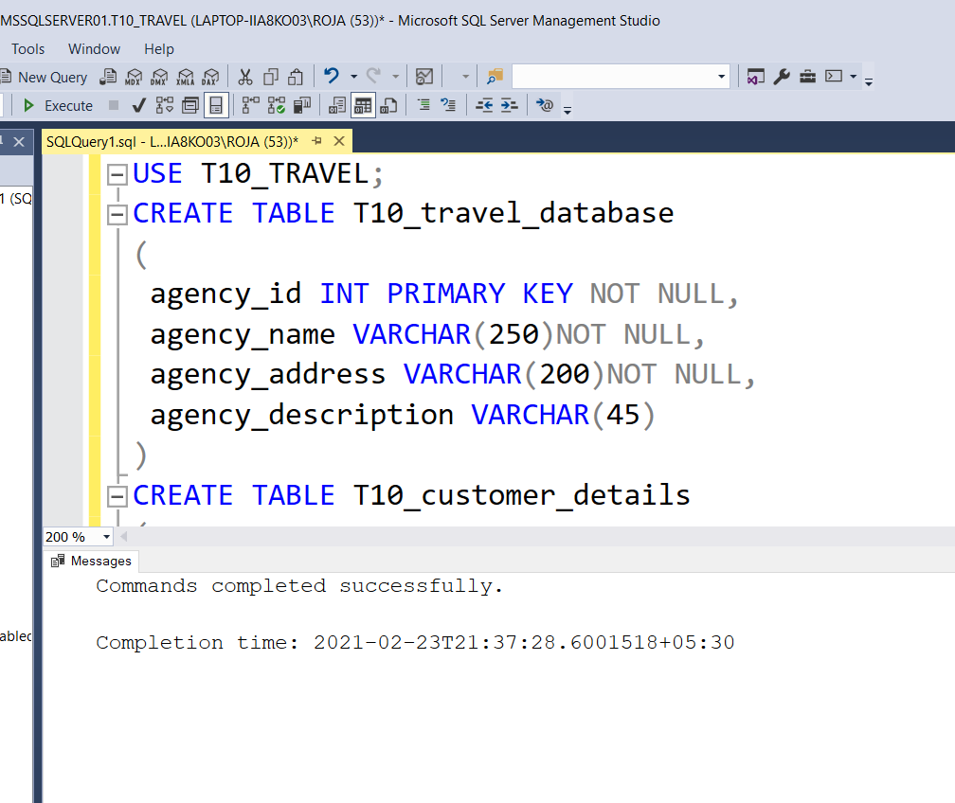

4.Drop table

QUERY

CREATE TABLE MY_BROTHER

(

First_Name VARCHAR(20) NOT NULL,

Last_Name VARCHAR(20) NOT NULL,

Phone_Number VARCHAR(12) NOT NULL,

DOB DATE NOT NULL,

Address_details TEXT

Intrests TEXT

)

DROP TABLE MY_BROTHER

OUTPUT:

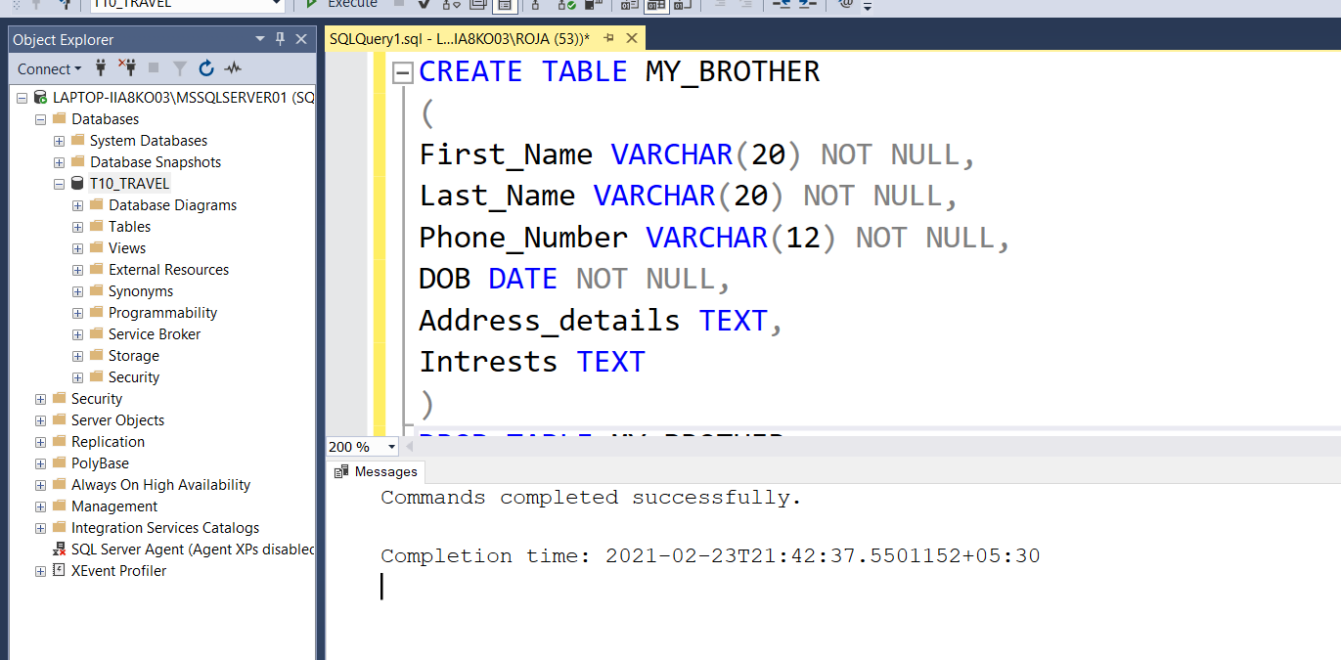

5.Show how to check the schema of the tables

QUERY

USE T10_TRAVEL;

EXEC sp_help T10_bookingdetails

OUTPUT:

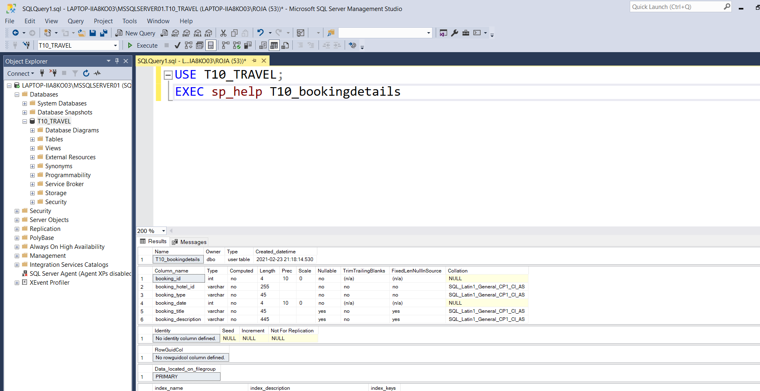

6. Show all the tables from the database (This is not done in class.)

QUERY

SELECT * FROM SYSOBJECTS WHERE xtype='U';

Output

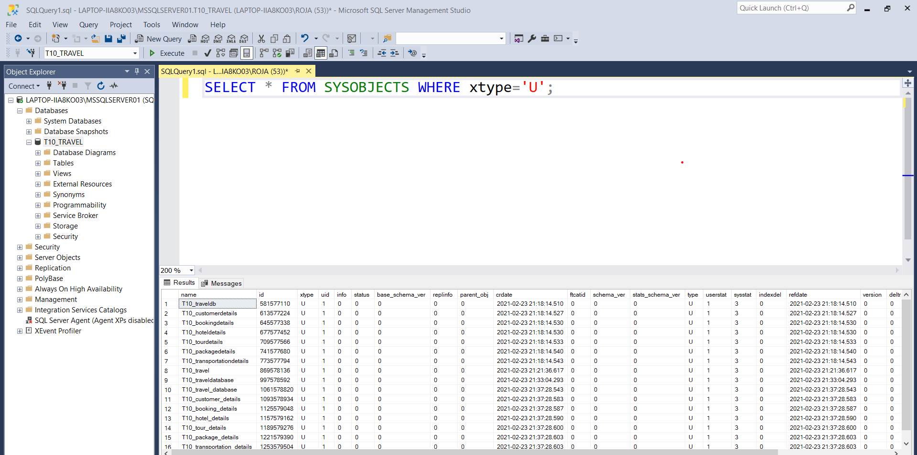

7.Create Table using Select Statement (I haven’t showed you this. I want you to try, it is very simple you should not have any problem).

QUERY

USE T10_TRAVEL;

SELECT package_id , package_name INFO package_info FROM T10_packagedetails.

Output

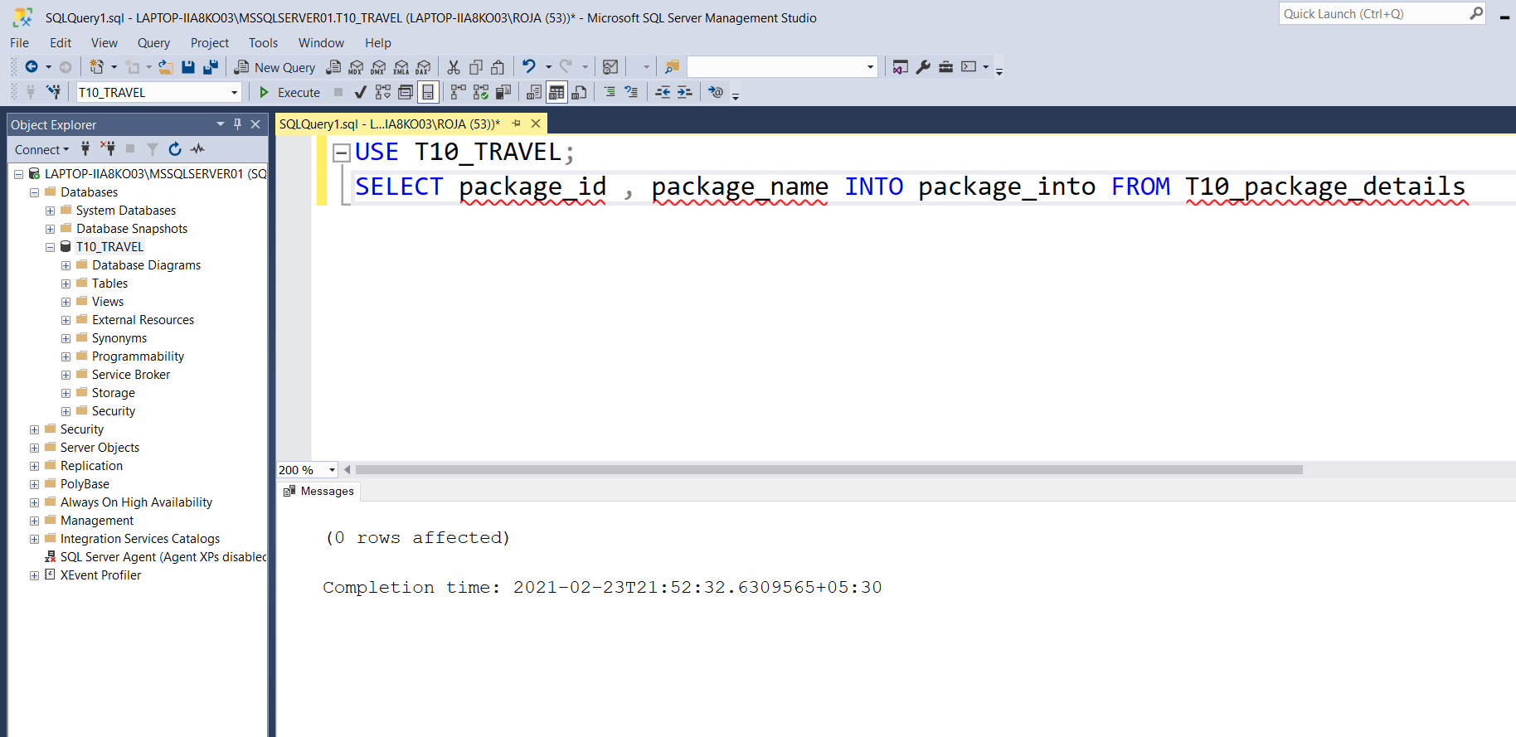

8.Create a table which has derived attribute. (Example can be Age is a derived attribute from Date of Birth. You should try this as well).

QUERY

CREATE TABLE MY_BROTHER_DETAILS

(

First_Name VARCHAR(20) NOT NULL,

Last_Name VARCHAR(20) NOT NULL,

Phone_Number VARCHAR(12) NOT NULL,

DOB DATE NOT NULL,

Age AS DATEDIFF(YEAR,DOB,GETDATE())

) ,

OUTPUT:

